clear
Fall 2021: If you have a health concern or question, Health Services will triage by phone to determine whether you are
in need of a telemedicine visits or in-person visit with a medical provider. This service is available to ALL RIC students in an attempt to address health and wellness needs but also conserve the use of masks and other protective gear. Our goal is to be here for you during this crisis so please call with questions or concerns.

Open M-F, 8:30-5pm, Browne Hall
401-456-8055 I http://www.ric.edu/healthservices

The Counseling Center offers a wide range of services to assist students in their efforts to learn and thrive during a life stage and in an environment of both great opportunity and challenge. Our primary function is to provide free, confidential counseling and psychotherapy for personal, career, and educational problems.

Fall 2021: Services provided at the Counseling Center are offered to all students whether they are living on or off campus. The Counseling Center is back in the office and seeing students in person, or if appropriate and preferred, virtually via Zoom. To schedule an appointment, you can call our office at 456-8094 or you can walk-in and schedule an appointment in person. We are located in Suite 100 in Browne Hall. We will also be offering several different group therapies, so ask your counselor or check our website if you are interested. If you are ever in need of immediate mental health support, the HOPE line is a 24/7/365 resource that provides access to immediate support from a licensed clinician over the phone. Call 456-HOPE (4673). This service is also free to RIC students and confidential within the Counseling Center.

The HOPE line has been established to provide continuous support to our campus community. If you are distressed or need support, Please call the 24/7 Rhode Island College HOPE line: 401-456-HOPE (4673).

Please note that if you are in need of immediate support, please dial 911 and proceed to your local emergency room.
Learning for Life (L4L) connects students to on and off campus resources and opportunities, empowering them to overcome obstacles on their journey to graduation. L4L’s team of trained Navigators serve as peer mentors for students and work to provide individualized support to meet student’s needs.

L4L strives to help build a community where students feel accepted, included, and safe. The L4Lnetwork of resources includes, support for everyday living such as food accessibility, transportation, childcare, housing, financial resources etc.

L4L is located in Adams Library, Level 1 and is open Monday- Friday 8:30 am to 4:30 pm.

Fall 2021: The best way to connect with their services is to email at l4linfo@ric.edu. They have virtual appointments available and will have contactless pick-up available for their food pantry.

They will also host free community lunches, workshops, and events. Visit the L4Lwebsite for more information or follow them on Instagram: @ricl4l or Facebook

CAMPUS LIFE

Student Organizations
Student Community Government
There are two Graduate Student representatives who serve on Student Community Government to ensure graduate student needs are considered in conversations regarding policies and programs. Information on SCG and schedules of meetings can be found here: http:/ /ricscg.org/sched ules/. Email: ricscg@ric.edu

Graduate Student Organizations
Graduate Students are encouraged to participate in student organizations. Lists of Student Organizations:
http://www.ric.edu/student-activities/Pages/Student-Organizations-Directory.aspx

The Graduate Student Organization serves as the central organization for Rhode Island College graduate students, to provide community, educational and advocacy opportunities for graduate students across all RIC departments. The Graduate Student organization prioritizes advocacy, community, diversity, education and professionalism. Email: sagrad@ric.edu or gso@so.ric.edu

The Rhode Island College Master of Social Work Student Organization (M SW SO ) serves as the central organization for the MSW program, advocating for students' rights, needs and concerns to enhance the educational experience. The MSWSO coordinates events, works with faculty to advocate for the student body, and is a vehicle for challenging and changing policies on campus and abroad. Email: mswso@so.ric.edu

Graduate Student Symposium
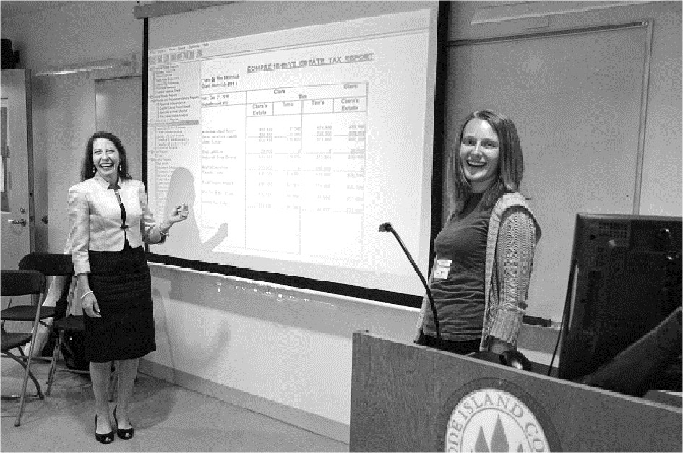
The Office of Graduate Studies holds a Graduate Student Symposium every May to showcase graduate student work. Please keep this opportunity in mind as you embark on research.

The event is free to participate in as well as to attend. All who wish to celebrate their peers and colleagues are welcome to attend. The schedule of events is distributed in the weeks leading up to symposium.

Student Employment
Graduate students who have completed a FASFA and have been awarded work study funds may work to claim those funds. Offices and programs on campus have positions to help students develop their professional experience.
If you have work study or are seeking employment on campus, check with the Career Development Office, Roberts Hall, Suite 117. Position postings can also be found on the Rhode Island College Destinations Job and Internships listing here. The Office of Graduate Studies can also help students find positions.
The Career Development Center hosts an annual Jobs & Internships Fair and Health, Human Services and Education Jobs & Internship fair during the spring semester. Information on these events and other networking opportunities can be found here: http://www.ric.edu/careerdevelopment/Pages/Tob-Fairs.aspx

Graduate Assistantships
30+ Graduate Positions are offered every year. Positions exist within all five academic schools - Faculty of Arts & Sciences, Feinstein School of Education and Human Development, School of Business, School of Nursing and School of Social Work - as well as student life and academic support offices around campus.

The positions are posted during the spring semester with applications due in March for the following academic year. Both part-time (10 hours) and full-time (20 hours) positions are offered.

Graduate Assistantships come with full or partial tuition waivers for course work at Rhode Island College, as well as a corresponding stipend dispersed throughout the academic year.

For more information on assistantships: http:/ /www.ric.edu/graduatestudies/Pages/Graduate-Assistant­ Opportunities.aspx

CAMPUS DIRECTORY

Graduate Studies Academic Offices Administration Offices

Office of the Dean of Graduate Studies
Gaige Hall 005, 401-456-4645, 401-456-9723
graduatestudies@ric.edu

Faculty of Arts & Sciences

Gaige Hall 120, 401-456-8106

Feinstein School of Education & Human Development

Building 2, 401-456-8896

School of Business

Alger Hall 203, 401-456-6367

School of Nursing

RI Nursing Education Center - Providence (Downtown) 100A 401-456-9612
Bursar's Office

East Campus, Building 4 Monday- Friday, 8:30-4:30
401-456-8130

Financial Aid

East Campus, Building 3 Monday-Friday, 8:30-4:30
401-456-8033

Records Office

East Campus, Building 4 Monday- Friday, 8:30-4:30
401-456-8213

School of Social Work

Guardo Hall (Building 9), 401-456-8042

Please see individual program listing for program directors and contact information here: http://www.ric.edu/graduatestudies/Pages/Graduate­ Degrees.aspx

Student & Academic Support Offices

Office of Academic Affairs
Dr. Helen Tate, VP I htate@ric.edu
Roberts Hall 401-456-8003

Division of Student Success
Dr. Ducha Hang dhang@ric.edu

Roberts Hall 401-456-8845
Academic Support (OASIS)
Christopher DaCosta, Diretor I cdacosta@ric.edu

Adams Library, Lower Level
Monday-Thursday, 8:00-7:00, Friday, 8-4:30

401-456-8083

Office of Diversity, Equity & Inclusion
Anna Cano Morales, AVP I acanomorales@ric.edu

Roberts Hall 301
401-456-9786

Counseling Center

Browne Hall

Monday-Friday, 8:30-4:30
401-456-8049

Disability Services Center
Keri Rossi-D'Entremont, Director I
krossi@ric.edu

Fogarty Life Science, 137 Monday- Friday, 8:30-4:30
401-456-2776 or TTY (via RI Relay) 711

Health Services

Browne Hall
Monday- Friday 7:30-5:00

401-456-8055

International Student Office
Dr. Karina Mascorro I kmascorro@ric.edu

Gaige Hall 325
Monday, Wednesday 10:00-4:00, Tuesday 10:00-2:00,

Thursday 1:30-4:30

Learning For Life (L4L)
Joise Garzon, Director I jgarzon@ric.edu

Adams Library, Lower Level
Monday-Thursday 8:00-6:00, Friday 8:00-4:30

401-456-6320
Title IX Office
Margaret Lynch-Gadaleta, Director I
mlynchgadaleta@ric.edu

Roberts Hall 301
401-456-8387

Unity Center

Donovan Dining Lower Level
Monday-Thursday 8:30-7:00, Friday 8:30-4:00

401-456-8791

User Support Services Help Center

Gaige Hall 105
Monday-Thursday 7:30-8:00, Friday 7:30-5:00

Saturday 8:00-2:00
helpdesk@ric.edu or 401-456-8033
Technical support is also available at the two campus computer labs.

Women's Center

Donovan Dining Lower Level
Monday-Thursday 9:00-6:00, Friday 9:00-5:00

401-456-8474

Writing Center

Adams Library, Lower Level
Monday-Thursday 9:00-7:00, Friday 9:00-4:00

401-456-8141
LGBTQ+ Affairs
Christopher Lee I clee@ric.edu

Unity Center (Donovan Dining Lower Level) 401-456-9033

Office of Student Life

Student Union 408
401-456-8061

