Name of Teacher Candidate________________________________ 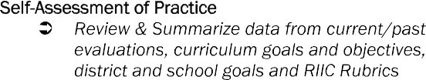

Final Goal/Objective | Details
Specific:
What, exactly, do I want to achieve/improve?

Measurable:
How will I know progress is being made?
How will I know I’ve achieved my goal?

Attainable:
How can this PGG be realistically attained?

Relevant:
What data supports the selection of this PGG?

Time Bound:
What is a measurable and realistic time line? Consider possible benchmarks.

Action Plan Steps: | Timeline
Supervising Professor Signature | Date
Cooperating Teacher Signature

RI-ICEE: SMART Goal Setting Process Form rev. 11.2017

