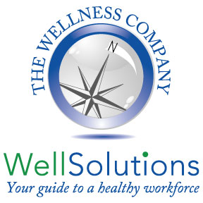
Rhode Island College
Shingrix Vaccination Clinic
Wednesday, May 4, 2022
11:00 AM – 1:30 PM
Location: The Yellow Cottage

No walk ins allowed - Registration deadline: May 3rd by noon
TO REGISTER, copy and paste this link in your browser:
https://fs30.formsite.com/thewellcomp/eufjclwrlc/index.html

What is shingles?
Shingles is a disease caused by the reawakening (or reactivation) of chickenpox virus. Common symptoms of shingles include a rash, usually along a nerve path, and severe pain. Sometimes the pain can last for months and it can be so debilitating that typical daily routines are disrupted.
How common is shingles?
Every year in the United States, shingles affects between 500,000 and 1 million people. Individuals have a 20-30 percent chance of getting shingles during their lifetime. About half of the people who live to 85 years old will get shingles. For more information, visit www.shingrix.com.
How can you avoid shingles?
If you have had chickenpox, you can get shingles. People who are 50 years of age or older can decrease their chance of getting shingles by getting the shingles vaccine. Shingrix vaccine is proven to be over 90% effective at preventing shingles.

How do I know if I need to be vaccinated?
Two doses, 2 to 6 months apart, are recommended for adults 50 and older. This vaccine is also recommended for people who have already gotten the live shingles vaccine (Zostavax). There is no live virus in this vaccine.

