UNDERGRADUATE CURRICULUM COMMITTEE (UCC)
PROPOSAL FORM

Cover page scroll over blue text to see further important instructions: [if not working select “COMMents on rollover” in your Word preferences under view] please read these.
N.B. ALL numbered categories in section (A) must be completed. Please do not use highlight to select choices within a category but simply delete the options that do not apply to your proposal (e.g. in A.2 if this is a course revision proposal, just delete the creation and deletion options and the various program ones, so it reads “course revision”) Do not delete any of the numbered categories—if they do not apply leave them blank. If there are no resources impacted please put “none” in each A. 7 category.
A.1. Course or program | Certificate of undergraduate study (cus) in geographic information systems
Replacing
A. 1b. Academic unit | Faculty of Arts and Sciences
A.2. Proposal type | Program: creation
A.3. Originator | Michelle Brophy-Baermann | Home department | Political Science
A.4. Context and Rationale  Note: Must include additional information in smart tip for all new programs | A geographic information system (GIS) links hardware, software, and people to collect, manage, analyze, map, store, update, and present a wide variety of data about human or animal populations, environmental events, and the places where they interact. Because GIS is a rapidly growing field in many sectors of the economy, over 200 colleges and universities across the US offer certificate, baccalaureate or graduate programs in GIS. URI offers a graduate GIS program. According to the online professional resource, “GISGeography” (October 24, 2022), RIC’s would be the first undergraduate GIS certificate in Rhode Island.  The CUS will consist of 4 courses already offered at RIC:  GEOG 201 Mapping Our Changing World (4)  GEOG 202 Geographic Information Systems I (4) (to be cross-listed as PBAD 202 effective in Fall 2023)  GEOG 308 Geographic Information Systems II (4) (to be cross-listed as PBAD 308 effective in Fall 2023)  GEOG 463 Internship in Geography (variable credit 4-6)  Under this proposal, the four courses will be combined in a way that is likely to appeal to students who seek a certificate with a distinct career pathway in geospatial analysis to complement their other field(s) of study.  GIS connects all manner of quantitative data to a base map by integrating location data (i.e., where things are) with all types of descriptive, analytic or predictive information (i.e., the conditions that exist—or will exist—at the place(s) under study). This provides a foundation for mapping and analysis that may be used in scientific research, the planning of government services, and almost every industrial sector where the presentation and analysis of spatial data may be an important factor in decision-making.  GIS helps users understand spatial patterns and provides a geographic context for making decisions that may range from allocating scarce public resources to understanding the potential market for a new product to the likely uneven spatial impacts of climate change on neighborhoods, cities and regions. Data is mapped in “layers” that superimpose information upon a base map (see Figure 1 below).  In every case, the benefits of GIS include improved communication of complex concepts in an accessible visual format for decision makers; precise analysis of the interactions between multiple data points and the places where they are measured; greater efficiency in the visualization of problems and their solutions in a spatial context; the ability to map and update socio-economic, cultural, and environmental trends across space and time; and a sound basis for more informed decision making in the public, private and nonprofit realms.  FIGURE 1: Simplified example of how a GIS system integrates discrete “data layers” drawn from multiple sources into a single map.  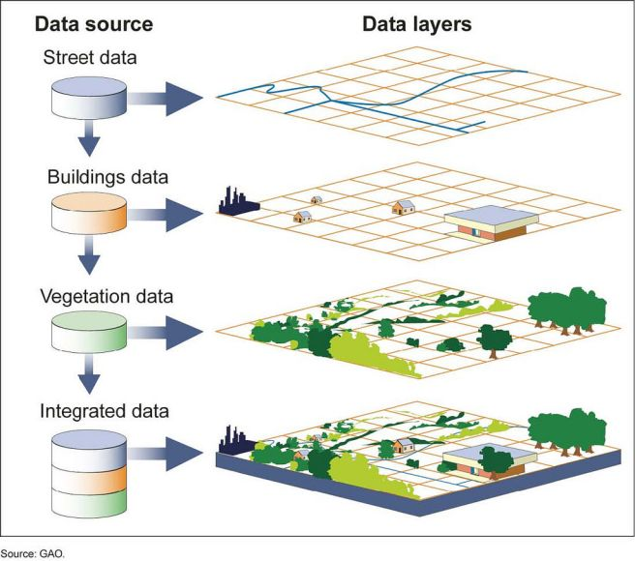  In its 2021 annual job growth forecast, the US Department of Labor’s Bureau of Labor Statistics projects that several GIS-related careers will see greater than average growth by 2029. These include urban and regional planners at 11 percent growth; database administrators, with 10 percent growth; environmental scientists and specialists at eight percent; and environmental science and protection technicians, also at eight percent. Finally, GIS information systems technologists and technicians are expected to see a seven to 10 percent growth during the same period.  RIC students who add the proposed CUS in GIS to their plans of study will benefit from developing a skill set that is likely to be highly marketable. The software company ESRI, Inc. includes in its inventory of sectors that employ GIS technicians/specialists at salaries ranging from $46,000-$88,000 (in 2021) the following: federal and state government human service agencies; utility companies; land surveyors; telecommunications companies; environmental and natural resource science consulting firms; emergency, public safety and other first responder facilities; climate science research institutes; transportation and civil engineering companies; mineral exploration firms; naturalists and animal migration researchers; hydrologists and water resource distribution planners; healthcare and epidemiology specialists; real estate and industrial/commercial facility re-location services; urban and regional planning offices; national security and defense agencies; and GPS, cartographic and navigation system designers.
A.5. Student impact  Must include to explain why this change is being made? | The Political Science Department expects that the proposed CUS in GIS will complement students’ existing programs of study, especially in the social sciences. The certificate would not compete with any other program. In addition, it should appeal to adult learners. The four courses that comprise the proposed CUS in GIS already exist in the Catalog and students have been able to enroll in them for many years:  For example, in addition to the social science disciplines, students in data science, computer science, computer information systems, management and marketing, and some of the healthcare policy-related fields might find a CUS in GIS appealing.  We expect that nontraditional students who are already employed in a variety of careers, but who do not have an undergraduate or pre-professional qualification, may be drawn to the CUS in GIS to improve their prospects for career advancement.  We do not foresee negative impacts for students or existing programs.
A.6. Impact on other programs | No impacts are anticipated
A.7. Resource impact | Faculty PT & FT: | None
 | Library: | None
 | Technology | None
 | Facilities: | None
A.8. Semester effective | Fall 2023 | A.9. Rationale if sooner than next Fall
A.10. INSTRUCTIONS FOR CATALOG COPY: Use the Word copy versions of the catalog sections found on the UCC Forms and Information page. Cut and paste into a single file ALL the relevant pages from the college catalog that need to be changed. Use tracked changes feature to show how the catalog will be revised as you type in the revisions. If totally new copy, indicate where it should go in the catalog. If making related proposals a single catalog copy that includes all changes is preferred. Send catalog copy as a separate single Word file along with this form.
A.11. List here (with the relevant urls), any RIC website pages that will need to be updated (to which your department does not have access) if this proposal is approved, with an explanation as to what needs to be revised:
A. 12 Check to see if your proposal will impact any of our transfer agreements, and if it does explain in what way. Please indicate clearly what will need to be updated. NONE
A. 13 Check the section that lists “Possible NECHE considerations” on the UCC Forms and Information page and if any apply, indicate what that might be here and contact Institutional Research for further guidance.

C. Program Proposals Complete only what is relevant to your proposal. Delete section C if not needed. PLease add in the 2020 CIP number for MAJOR revisions or new programs in C. 2; these can be found at https://nces.ed.gov/ipeds/cipcode/browse.aspx?y=56 consult with Institutional research to be sure you select the correct one.

 | Old (for revisions only) | New/revised
C.1. Enrollments  Must be completed. |  | Target enrollment for Year 1 = 6-8 students; for Year 2 = 8-10 students; for year 3 = 10-14 students; for Year 4 and thereafter = 14-20 students annually.
C. 2. 2020 CIP number |  | 45.0702
C.3. Admission requirements |  | [Same as for RIC]
C.4. Retention requirements |  | [Same as for RIC]
C.5. Course requirements for each program option. Show the course requirements for the whole program here. |  | GEOG 201 Mapping our Changing World (existing RIC course, 4 credits, required)  GEOG 202 Geographic Information Systems I (existing RIC course to be newly cross-listed in the Public Administration Major as PBAD 202, 4 credits, required)  GEOG 308 Geographic Information Systems II (existing RIC course to be newly cross-listed in the Public Administration Major as PBAD 308, 4 credits, required)  GEOG 463 Internship in Geography (existing RIC course, 4-6 credits, required)
C.6. Credit count for each program option |  | 16-18 credits (there are no program options within the CUS in GIS)
C.7. Program Accreditation (if relevant) |  | N/A
C.8 Is it possible that the program will be more than 50% online (includes hybrid)?* |  | NO . We will initially only offer this program fully in person.
C.9 Will any classes be offered at sites other than RIC campus or the RI Nursing Ed. Center?* |  | NO
C. 10. Do these revisions reflect more than 25% change to the program?* |  | N/A (New Program)
C.11. Program goals  Needed for all new programs |  | Students’ ability to conceive, design and carry out a policy-relevant mapping project will be continually assessed throughout GEOG 201, GEOG/PBAD 202 and GEOG/PBAD 308. In all cases, the key assessment measures are (i) the sources, quality and precision of a map’s underlying data; (ii) the accuracy with which that data is applied to appropriate map layers as the final map product is assembled; and (iii) the legibility of the final map and the clarity of the narrative that describes the processes used to create it and that articulates its relevance to a given policy question or challenge. Based on students’ thematic interests, career goals, and type of preparation, the internship course (GEOG 463) will be customized for each student so that they are positioned to improve their GIS and related cartographic skills in a professional workplace environment.
C.12. Other changes if any
* If answered YES to either of these questions will need to inform Institutional Research and get their acknowledgement on the signature page.

D. Signatures
- Changes that affect General Education in any way MUST be approved by ALL Deans and COGE Chair.
- Changes that directly impact more than one department/program MUST have the signatures of all relevant department chairs, program directors, and their relevant dean (e.g. when creating/revising a program using courses from other departments/programs). Check UCC manual 4.2 for further guidelines on whether the signatures need to be approval or acknowledgement.
- Proposals that do not have appropriate approval signatures will not be considered.
- Type in name of person signing and their position/affiliation.
- Send electronic files of this proposal and accompanying catalog copy to curriculum@ric.edu to the current Chair of UCC. Check UCC website for due dates. Do NOT convert to a .pdf.

D.1. Approvals: required from programs/departments/deans who originate the proposal. THESE may include multiple departments, e.g., for joint/interdisciplinary proposals.
Name | Position/affiliation | Signature | Date
Michelle Brophy-Baermann | Chair of Political Science | 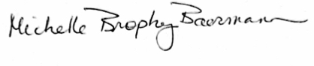 | 11/20/22
Earl Simson | Dean of FAS | *Approved via email | 11/21/22

D.2. Acknowledgements: REQUIRED from OTHER PROGRAMS/DEPARTMENTS (and their relevant deans if not already included above) that are IMPACTED BY THE PROPOSAL. SIGNATURE DOES NOT INDICATE APPROVAL, ONLY AWARENESS THAT THE PROPOSAL IS BEING SUBMITTED. CONCERNS SHOULD BE BROUGHT TO THE UCC COMMITTEE MEETING FOR DISCUSSION; all faculty are welcome to attend.
Name | Position/affiliation | Signature | Date
Jen Giroux | Interim VP of Corp Relations and Professional Studies |  | 11/21/22
 |  |  | Tab to add rows

