UNDERGRADUATE CURRICULUM COMMITTEE (UCC)
PROPOSAL FORM

Cover page scroll over blue text to see further important instructions: [if not working select “COMMents on rollover” in your Word preferences under view] please read these.
N.B. ALL numbered categories in section (A) must be completed. Please do not use highlight to select choices within a category but simply delete the options that do not apply to your proposal (e.g. in A.2 if this is a course revision proposal, just delete the creation and deletion options and the various program ones, so it reads “course revision”) Do not delete any of the numbered categories—if they do not apply leave them blank. If there are no resources impacted please put “none” in each A. 7 category.
A.1. Course or program | POL 102 AMERICAN GOVERNMENT  POL 103 GLOBAL POLITICS  POL 104 INTRODUCTION TO POLITICAL THOUGHT
Replacing | POL 202 AMERICAN GOVERNMENT  POL 203 GLOBAL POLITICS  POL 204 INTRODUCTION TO POLITICAL THOUGHT
A. 1b. Academic unit | Faculty of Arts and Sciences
A.2. Proposal type | Course revision:
A.3. Originator | Michelle Brophy-Baermann | Home department | Political Science Dept.
A.4. Context and Rationale  Note: Must include additional information in smart tip for all new programs | The Department of Political Science seeks to re-number its three “gateway” courses from the 200 to the 100 level, so that they are clearly recognized by students as entry-level courses and viewed by them as introductions to core concepts in political science. Under this proposal POL 202 American Government, becomes POL 102; POL 203 Global Politics becomes POL 103; and POL 204 Introduction to Political Thought becomes POL 104; all with their titles unchanged.  There are no changes to the title, content, syllabus, mode of instruction, course learning outcomes, or student assessment protocols of these courses, so there was no need to include topical outlines.  Many courses use these three POL courses as a prerequisite and we are hoping these can all be updated without needing a separate proposal for each but by following this list:  The POL 202 course is used as a prerequisite for ELED 436 and several POL courses (300, 301W, 306, 307, 308W, 309, 331, 332, 334, 353, 354, 355, 358, 359, and 456 which will all need to be revised), also PBAD 326, and SWRK 301.  The POL 203 course is used as a prerequisite for INGO 300, POL 303, POL 341, POL 345, POL 346, and POL 348.  The POL 204 course is used as a prerequisite for POL 316.
A.5. Student impact  Must include to explain why this change is being made? | No impacts on students are anticipated beyond an enhanced awareness among incoming students and their academic advisors that POL 102, POL 103 and POL 104 are appropriate for freshmen.
A.6. Impact on other programs | All three are existing courses and, in every respect, will remain unchanged under the proposed renumbering. They are Gen. Ed. “SB” courses, but do not need re-approval from COGE because the only request made is for a new course number, which will enable them to be more “visible” to freshmen. Gen. Ed. Program and Gen. Ed. students will be unaffected, but because there will be necessary changes to the listing for this course in the Gen. Ed. sections of the Catalogue, the department includes signatures from the COGE chair and the five academic deans. Aside from the Political science major and minor, POL 202 and 203 are used as restricted electives in the Environmental Studies major and minor and the Justice Studies major and minor. While POL 202 is used in the Public Administration major, the ELED Teaching Concentration in Middle Level General Science and Middle Level Mathematics, and ELED BS, for the Secondary Education History major certification courses, SED Social Studies major, and BSW major. The POL 203 course is also used in the INGOS and NPST CUS and minor, the Global Studies major and minor, and the International Business minor; POL 203 and POL 204 are used in the ELED Multidisciplinary and Social Studies majors, and the SED Social Studies major; and POL 204 is used in the Philosophy Minor in Logical and Ethical Reasoning,
A.7. Resource impact | Faculty PT & FT: | No impact
 | Library: | No impact
 | Technology | No impact
 | Facilities: | No impact
A.8. Semester effective | Fall 2023 | A.9. Rationale if sooner than next Fall |  | None
A.10. INSTRUCTIONS FOR CATALOG COPY: Use the Word copy versions of the catalog sections found on the UCC Forms and Information page. Cut and paste into a single file ALL the relevant pages from the college catalog that need to be changed. Use tracked changes feature to show how the catalog will be revised as you type in the revisions. If totally new copy, indicate where it should go in the catalog. If making related proposals a single catalog copy that includes all changes is preferred. Send catalog copy as a separate single Word file along with this form.
A.11. List here (with the relevant urls), any RIC website pages that will need to be updated (to which your department does not have access) if this proposal is approved, with an explanation as to what needs to be revised:
A. 12 Check to see if your proposal will impact any of our transfer agreements, and if it does explain in what way. Please indicate clearly what will need to be updated. Since POL 202, 203 and 204 are all courses that regularly transfer, these new numbers will need to be fixed on TES.
A. 13 Check the section that lists “Possible NECHE considerations” on the UCC Forms and Information page and if any apply, indicate what that might be here and contact Institutional Research for further guidance. No impact

B. NEW OR REVISED COURSES Delete section B if the proposal does not include a new or revised course. As in section A. do not highlight but simply delete suggested options not being used. Always fill in b. 1 and B. 3 for context. NOTE: course learning outcomes and topical outlines only needed for new or substantially revised courses.
 | Old (for revisions only)  ONLY include information that is being revised, otherwise leave blank. | New  Examples are provided within some of the boxes for guidance, delete just the examples that do not apply.
B.1. Course prefix and number | POL 202  POL 203  POL 204 | POL 102  POL 103  POL 104
B.2. Cross listing number if any
B.3. Course title
B.4. Course description
B.5. Prerequisite(s)
B.6. Offered
B.7. Contact hours
B.8. Credit hours
B.9. Justify differences if any
B.10. Grading system
B.11. Instructional methods
B.11.a Delivery Method
B.12. CATEGORIES
12. a. How to be used
12 b. Is this an Honors  course? | NO | NO
12. c. General Education  N.B. Connections must include at  least 50% Standard Classroom  instruction. | YES | YES
12. d. Writing in the  Discipline (WID) | NO | NO
B.13. How will student performance be evaluated?
B.14 Recommended class-size
B.15. Redundancy statement
B. 16. Other changes, if any

B.17. Course learning outcomes: List each one in a separate row | Professional Org.Standard(s), if relevant | How will each outcome be measured?
Unchanged from existing courses | N/A | Unchanged from existing courses

B.18. Topical outline: DO NOT INSERT WHOLE SYLLABUS, JUST A TWO-TIER TOPIC OUTLINE suitable for the contact hours requested. Proposals that ignore this request will be returned for revision. Unchanged from existing courses.

D. Signatures
- Changes that affect General Education in any way MUST be approved by ALL Deans and COGE Chair.
- Changes that directly impact more than one department/program MUST have the signatures of all relevant department chairs, program directors, and their relevant dean (e.g. when creating/revising a program using courses from other departments/programs). Check UCC manual 4.2 for further guidelines on whether the signatures need to be approval or acknowledgement.
- Proposals that do not have appropriate approval signatures will not be considered.
- Type in name of person signing and their position/affiliation.
- Send electronic files of this proposal and accompanying catalog copy to curriculum@ric.edu to the current Chair of UCC. Check UCC website for due dates. Do NOT convert to a .pdf.

D.1. Approvals: required from programs/departments/deans who originate the proposal. THESE may include multiple departments, e.g., for joint/interdisciplinary proposals.
Name | Position/affiliation | Signature | Date
Michelle Brophy-Baermann | Chair of Political Science | 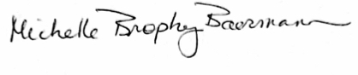 | 11/20/22
Earl Simson | Dean of FAS | *Approved via email | 11/21/22

D.2. Acknowledgements: REQUIRED from OTHER PROGRAMS/DEPARTMENTS (and their relevant deans if not already included above) that are IMPACTED BY THE PROPOSAL. SIGNATURE DOES NOT INDICATE APPROVAL, ONLY AWARENESS THAT THE PROPOSAL IS BEING SUBMITTED. CONCERNS SHOULD BE BROUGHT TO THE UCC COMMITTEE MEETING FOR DISCUSSION; all faculty are welcome to attend.
Name | Position/affiliation | Signature | Date
Joe Zornado | Chair of COGE |  | 11/22/222
Earl Simson | Dean FAS | *Acknowledged via email | 11/21/2022
Marianne Raimundo | Dean Business | *Acknowledged via email | 11/29/2022
Carolynn Masters | Dean Nursing | 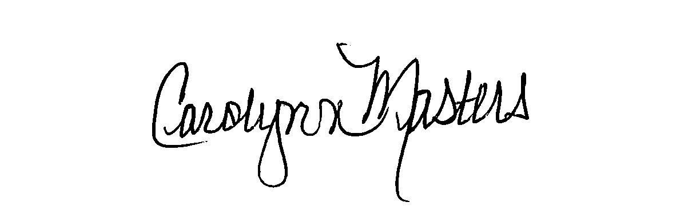 | 11/21/22
Jay Nimmagadda | Dean Social Work | *Acknowledged via email via email | 11/22/2022
April Kiser | Director Environmental Studies and Global Studies | *Acknowledged via email via email
Robyn Linde | Director INGOS | 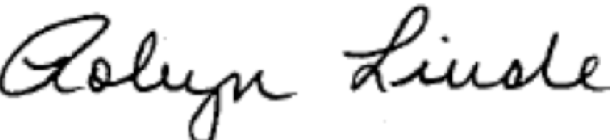 | 11-21-2022
Charles McLaughlin | Chair Ed. Studies | Charles H. McLaughlin, Jr. | 11/26/2022
Jeannine Dingus-Eason | Dean Education |  | 11/21/2022
Kemal Saatcioglu | Faculty advisor for International Business Minor | *Acknowledged via email | 11/21/2022
Constance Milbourne | Chair Management and Marketing | *Acknowledged via email | 11/28/2022
Carse Ramos | Chair of Sociology | *Acknowledged via email | 11/22/2022
Eliani Basile | Chair Modern Languages | Eliani Basile | 11/22/2022
David Ramirez | Director Latin American Studies | *Acknowledged via email | 11/22/2022
Jeff Harkness | Director Justice Studies | *Acknowledged via email | 11/21/2022
Carolyn Obel-Omia | Chair ELED | *Acknowledged via email | 11/28/2022
Glenn Rawson | Chair Philosophy | *Acknowledged via email | 11/22/2022

