UNDERGRADUATE CURRICULUM COMMITTEE (UCC)
PROPOSAL FORM

Cover page scroll over blue text to see further important instructions: [if not working select “COMMents on rollover” in your Word preferences under view] please read these.
N.B. ALL numbered categories in section (A) must be completed. Please do not use highlight to select choices within a category but simply delete the options that do not apply to your proposal (e.g. in A.2 if this is a course revision proposal, just delete the creation and deletion options and the various program ones, so it reads “course revision”) Do not delete any of the numbered categories—if they do not apply leave them blank. If there are no resources impacted please put “none” in each A. 7 category.
A.1. Course or program | PSYC 427 Psychology in the workplace
Replacing
A. 1b. Academic unit | Faculty of Arts and Sciences
A.2. Proposal type | Course: creation
A.3. Originator | Christine Marco | Home department | Psychology
A.4. Context and Rationale  Note: Must include additional information in smart tip for all new programs | This new course is proposed as part of a program revision. The overall revision (explained on the proposal form) focuses on increasing options for students that allow greater flexibility of scheduling, represent the current state of the discipline, meet students’ educational goals, and/or are relevant for responsible citizenry in the current world.  The field of industrial-organizational psychology (also called I/O psychology) involves the scientific study of human behavior in the workplace. I/O psychologists are scientist-practitioners who have expertise in the design, execution and interpretation of research in psychology and who apply their findings to help address human and organizational problems in the context of work.  In this course, students will learn how psychology theories and research apply to workplace settings for a more successful and fulfilling work career. Please note, although the department of Management offers a course in Organizational Behavior (MGT 322), their program focuses on developing managers (quote from their webpage says “You will learn, among other skills, how to create a coherent organizational strategy, how to make the optimal use of resources, how to analyze data for managerial decision making and how to develop recommendations to keep the organization moving forward.”) However, our proposed course is broader and is relevant to improving the work life of any student entering the workforce, not just those pursing management careers. Our course provides information for all workers to understand what makes work life more successful, including how they can contribute to improving their own workplace success and satisfaction. Furthermore, the practice of I/O psychology is relevant to multiple work settings including business, industry, labor, public (including non-profit), academic, community and health organizations. This proposed course will benefit students across all work-related settings.
A.5. Student impact  Must include to explain why this change is being made? | Students will have more flexible options for fulfilling their upper-level course program requirements.
A.6. Impact on other programs | None
A.7. Resource impact | Faculty PT & FT: | Will be taught by existing faculty. To allow for the scheduling and staffing of these courses, other upper-level courses that currently are scheduled more frequently (e.g., multiple sections of Child Psychology per year) will now be offered annually instead.
 | Library: | None – existing resources are sufficient
 | Technology | None – existing resources are sufficient
 | Facilities: | None – only need a regular classroom
A.8. Semester effective | Fall 2023 | A.9. Rationale if sooner than next Fall
A.10. INSTRUCTIONS FOR CATALOG COPY: Use the Word copy versions of the catalog sections found on the UCC Forms and Information page. Cut and paste into a single file ALL the relevant pages from the college catalog that need to be changed. Use tracked changes feature to show how the catalog will be revised as you type in the revisions. If totally new copy, indicate where it should go in the catalog. If making related proposals a single catalog copy that includes all changes is preferred. Send catalog copy as a separate single Word file along with this form.
A.11. List here (with the relevant urls), any RIC website pages that will need to be updated (to which your department does not have access) if this proposal is approved, with an explanation as to what needs to be revised:

n/a
A. 12 Check to see if your proposal will impact any of our transfer agreements, and if it does explain in what way. Please indicate clearly what will need to be updated.

n/a

A. 13 Check the section that lists “Possible NECHE considerations” on the UCC Forms and Information page and if any apply, indicate what that might be here and contact Institutional Research for further guidance.

n/a

B. NEW OR REVISED COURSES Delete section B if the proposal does not include a new or revised course. As in section A. do not highlight but simply delete suggested options not being used. Always fill in b. 1 and B. 3 for context. NOTE: course learning outcomes and topical outlines only needed for new or substantially revised courses.
 | Old (for revisions only)  ONLY include information that is being revised, otherwise leave blank. | New  Examples are provided within some of the boxes for guidance, delete just the examples that do not apply.
B.1. Course prefix and number |  | PSYC 427
B.2. Cross listing number if any
B.3. Course title |  | Psychology in the Workplace
B.4. Course description |  | Students apply psychology theories and research to understand human behavior in the workplace. Topics include leadership, working in groups, and employee motivation and wellbeing.
B.5. Prerequisite(s) |  | PSYC 221 or PSYC 221W, and 45 completed credits that include 8 additional PSYC credits.
B.6. Offered |  | Annually
B.7. Contact hours |  | 4
B.8. Credit hours |  | 4
B.9. Justify differences if any
B.10. Grading system |  | Letter grade
B.11. Instructional methods |  | Lecture
B.11.a Delivery Method |  | On campus | Asynchronous | Synchronous | Hybrid  50% Online |
B.12. CATEGORIES  12. a. How to be used |  | Restricted elective for major/minor
12 b. Is this an Honors  course? |  | NO
12. c. General Education  N.B. Connections must include at  least 50% Standard Classroom  instruction. |  | NO
12. d. Writing in the  Discipline (WID) |  | NO
B.13. How will student performance be evaluated? |  | Instructors of different sections will likely have different learning assessments and/or weight them differently, but will select from:  Attendance | Class participation | Exams | Presentations |Papers |  Class Work | Quizzes | Projects |
B.14 Recommended class-size |  | 30
B.15. Redundancy statement |  | Although the department of Management offers a course in Organizational Behavior (MGT 322), the focus of their course is on developing managers. However, our proposed course goes beyond that and is relevant to improving the work life of any student entering the workforce, not just those pursing management careers. Our course provides information for all workers to understand what makes work life more successful, including how they can contribute to improving their own workplace success and satisfaction. We therefore do not view this course as covering the same instruction as the MGT 322 course.
B. 16. Other changes, if any

B.17. Course learning outcomes: List each one in a separate row | Professional Org.Standard(s), if relevant | How will each outcome be measured?
Demonstrate knowledge in general core domains of industrial/organizational psychology, |  | See B. 13
Demonstrate knowledge of the application of psychology theory and research to understanding workplace issues |  | See B. 13
Demonstrate knowledge of diversity topics for psychology in workplace. |  | See B. 13
Communicate orally and in writing regarding the course material |  | See B. 13
Demonstrate self-awareness and reflection on one’s own work performance and career development. |  | See B. 13

B.18. Topical outline: DO NOT INSERT WHOLE SYLLABUS, JUST A TWO-TIER TOPIC OUTLINE suitable for the contact hours requested. Proposals that ignore this request will be returned for revision.
Introduction
- Overview of Industrial/Organizational Psychology
- The multicultural nature of modern work
- The Science of Industrial/Organizational Psychology

Individual Differences and Assessment
- Understanding & measuring work-related attributes: Cognition, personality, skills, emotional intelligence
- Psychometrics and ethics in testing and assessment

Job Analysis and Performance
- Models of job performance
- Theories and practices of job analysis and performance ratings
- Performance feedback

Attitudes, Motivation, Emotion and Workplace behavior
- Motivation theory in I-O Psychology / Meaning and importance of motivation in the workplace
- Cross-cultural and inter-generational aspects of work motivation
- The experience of emotion at work
- Employee engagement & job satisfaction
- Work-related attitudes and emotions from cross-cultural perspectives

Work-related Stress and Well-Being
- Definitions and models of work stress & impact on mental and physical health
- Individual differences in resistance to stress
- Primary, secondary, and tertiary strategies for stress prevention
- Violence at work
- Work-life balance

Fairness, Justice, and Diversity in the Workplace
- The concepts of justice, fairness, and trust
- Diversity in the workplace
- Approaches to organizational justice

Leadership in Organizations
- The Concept of Leadership
- Theories of Leadership
- Individual differences and leadership: Gender & cross-cultural topics

Teamwork & Group dynamics
- Types of Teams
- Team Processes / Group dynamics
- Team Development
- Cross-cultural and other diversity in teamwork behavior

D. Signatures
- Changes that affect General Education in any way MUST be approved by ALL Deans and COGE Chair.
- Changes that directly impact more than one department/program MUST have the signatures of all relevant department chairs, program directors, and their relevant dean (e.g. when creating/revising a program using courses from other departments/programs). Check UCC manual 4.2 for further guidelines on whether the signatures need to be approval or acknowledgement.
- Proposals that do not have appropriate approval signatures will not be considered.
- Type in name of person signing and their position/affiliation.
- Send electronic files of this proposal and accompanying catalog copy to curriculum@ric.edu to the current Chair of UCC. Check UCC website for due dates. Do NOT convert to a .pdf.

D.1. Approvals: required from programs/departments/deans who originate the proposal. THESE may include multiple departments, e.g., for joint/interdisciplinary proposals.
Name | Position/affiliation | Signature | Date
Tom Malloy | Chair of Psychology | *approved by e-mail | 3/2/2023
Earl Simson | Dean of FAS | *approved by e-mail | 3/2/2023

D.2. Acknowledgements: REQUIRED from OTHER PROGRAMS/DEPARTMENTS (and their relevant deans if not already included above) that are IMPACTED BY THE PROPOSAL. SIGNATURE DOES NOT INDICATE APPROVAL, ONLY AWARENESS THAT THE PROPOSAL IS BEING SUBMITTED. CONCERNS SHOULD BE BROUGHT TO THE UCC COMMITTEE MEETING FOR DISCUSSION; all faculty are welcome to attend.
Name | Position/affiliation | Signature | Date
David Blanchette/Michael Casey | Co-chairs Management/Marketing | 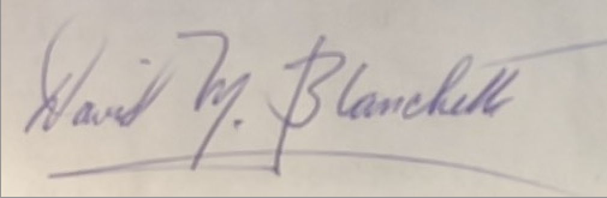 | 3/13/23
Marianne Raimondo | Interim Dean SOB | 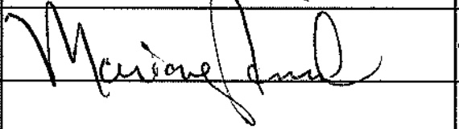 | 3/15/23
 |  |  | Tab to add rows

