graduate COMMITTEE
curriculum PROPOSAL FORM

A. Cover page (rover over text for more instructions- please delete red instructions)

A.1. Course or program | NURS 536 ADVANCED PHYSIOLOGY II
Replacing | BIOL 536 ADVANCED PHYSIOLOGY II
Academic Unit | | School of Nursing |
A.2. Proposal type | Course: creation |
A.3. Originator | Justin DiLibero |  | Home department |  | Graduate Nursing
A.4. Rationale  Additional Information for new programs | BIOL 535 and BIOL 536 have historically been provided by the biology department; however, no biology faculty was available to teach the course in Spring of 2023. This necessitated the identification of an alternative faculty to teach the course. While biology faculty are expert in the field of physiology, they lack the clinical expertise of the anesthesia field necessary to help students draw connections between academic concepts and clinical practice. Best pedagogical strategies in nursing education require the bridging of theory and lecture concepts in clinical practice, and clinical knowledge and experiences into didactic courses (Benner, et al., 2010). Feedback from students has consistently reflected an opportunity to better integrate clinical knowledge and concepts into BIOL 535 and 536.  With the change of the Nurse Anesthesia program to the doctoral level the demands of the program are higher than ever before. It is essential that the curriculum is designed to efficiently provide students a strong command of foundational concepts and the ability to easily translate this knowledge into practice.  The purpose of this proposal is to move the advanced Physiology courses from Biology to Nursing. This change was brought about by trying to collaboratively solve staffing of the courses by both nursing and the Chair of Biology. Moving the courses to the nursing department allows the courses to be taught by faculty who are experienced clinicians, hold a deep knowledge of physiology and pathophysiology, and can better facilitate student’s ability to bridge connections between didactic content and clinical practice.  Reference  Benner, P Sutphen, M., Leonard, V., Day, L. (2010). Educating nurses: A call for radical transformation. Jossey-Bass.
A.5. Student impact | This model will continue to provide students with advanced knowledge of physiology while better supporting students to bridge connections between didactic knowledge and clinical practice.
A.6. Impact on other programs | Historically, these courses have been taught by faculty in the Biology department. The courses are available to students in the nurse anesthesia program only. In the Spring of 2023 no biology faculty was available to teach this course. This change is not expected to have a significant impact on other departments or programs.
A.7. Resource impact | Faculty PT & FT: | As above.
 | Library: | None
 | Technology | None
 | Facilities: | None
A.8. Semester effective | Spring 2023 | A.9. Rationale if sooner than next Fall |  | No biology faculty is available to teach the course in Spring of 2023.
A.10 Changes to the website | Catalog changes only

B. NEW OR REVISED COURSES

 |  | Old (for revisions only)  ONLY include information that is being revised, otherwise leave blank |  | New  Examples are provided within some of the boxes for guidance, delete just the examples that do not apply.
B.1. Course prefix and number |  |  |  | NURS 536
B.2. Cross listing number if any |  |  |  | None
B.3. Course title |  |  |  | Advanced Physiology II
B.4. Course description |  |  |  | Continuation of the examination of human physiologic concepts. This course will utilize a systems approach to the topics of renal and acid-base, gastrointestinal, and endocrine concepts.
B.5. Prerequisite(s) |  |  |  | Enrollment in the Nurse Anesthesia option or permission of DNP Program Director
B.6. Offered |  |  |  | Spring
B.7. Contact hours
B.8. Credit hours |  |  |  | 4 credit hours
B.9. Justify differences if any
B.10. Grading system |  |  |  | Letter grade |
B.11. Instructional methods |  |  |  | | Lecture |
B.11.a Delivery Method |  |  |  | |Hybrid
B.12.Categories |  |  |  | Required for program |
B.13. How will student performance be evaluated? |  | Attendance | Class participation | Clinical work | Exams | Fieldwork | Presentations | Papers |  Class Work | Interviews | Quizzes |  Performance Protocols | Projects |  | Reports of outside supervisor | Studio work |  | Attendance | Class participation | | Exams | Presentations | Papers |
B.14. Redundancy with, existing courses
B. 15. Other changes, if any
B.16. Course learning outcomes: List each outcome in a separate row | Professional organization standard(s), if relevant |  | How will each outcome be measured?

B.17. Topical outline
- Blood Cells, Immunity and Coagulation
- Respiratory physiology
  - Structure of the respiratory system
  - Lung volumes and capacity
  - Mechanics of breathing
  - Gas exchange
  - Carbon dioxide transport
  - Ventilation/perfusion relationships
  - Control of breathing
  - Integrative function
  - Hypoxemia and Hypoxia
- Gastrointestinal physiology
  - Structure of the GI Tract
  - Gastrointestinal Peptides
  - Motility
  - Secretion
  - Digestion and Absorption
  - Intestinal fluid and electrolyte transport
  - Liver Physiology
- Endocrine Physiology
  - Hormone Synthesis
  - Regulation of hormone secretion
  - Regulation of hormone receptors
  - Mechanisms of hormone action and second messengers
  - Hypothalamic-Pituitary relationships
  - Anterior lob hormones
  - Posterior lobe hormones
  - Thyroid hormone
  - Adrenal medulla and cortex
  - Endocrine pancreas
  - Regulation of calcium and phosphate metabolism
- Reproductive Physiology
  - Sexual differentiation
  - Puberty
  - Male reproductive physiology
  - Female reproductive physiology
- Neurophysiology
- Organization of the Nervous system
- Sensory systems
- Somatosensory system and pain
- Vestibular system
- Olfaction
- Taste
- Motor Systems

D. Signatures

D.1. Approvals:

Required from department chairs, program directors, and deans from the academic unit originating the proposal.
Name | Position/affiliation | Signature | Date
Kara Misto | Program Director of DNP | 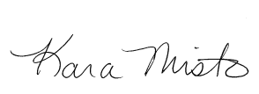 | 11/3/2022
Justin DiLibero | Chair of Graduate Nursing | Justin DiLibero | 11/1/2022
Carolynn Masters | Dean of Nursing | 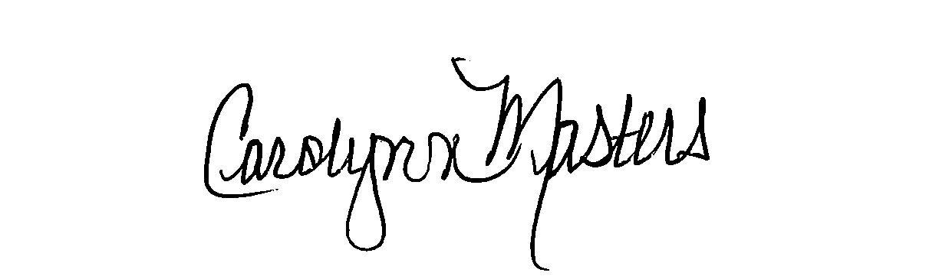 | 11/17/22

D.2. Acknowledgements:

Required from all departments (and corresponding dean) impacted by the proposal. Signature does not indicate approval. Concerns should be brought to the attention of the graduate committee chair for discussion.

Name | Position/affiliation | Signature | Date
Dana Kolibachuk | Chair of Biology | Dana J Kolibachuk | 11/18/22
Earl Simson | Dean FAS | Earl Simson | 1/31/23

