graduate COMMITTEE
curriculum PROPOSAL FORM

A. Cover page

A.1. Course or program | New Course: SPED 547
Academic Unit | School of Education
A.2. Proposal type | Course: creation
A.3. Originator | Susan Dell |  | Home department |  | SPED
A.4. Rationale  Additional Information for new programs | The Right to Read Acts ensures that educators who teach ALL LEARNERS extend their own knowledge of literacy. A three-course sequence on literacy for students with Severe Intellectual Disability (SID) was submitted to RI Dept. of Education to address the requirements for teachers of students with SID and was approved in early March 2023.  The first two courses in the sequence (READ 534 and SPED 546) are approved existing courses. SPED 547 (this new course proposal) provides a 4-credit extension to the READ 534 and SPED 546, applying previous knowledge to reading instruction for students with Severe Intellectual Disability. SPED 547 introduces extension content with a practicum application of teaching reading to students with complex learning needs.
A.5. Student impact | SPED 547 provides students coursework that addresses specific needs identified by teachers of students with SID not available anywhere in RI.
A.6. Impact on other programs
A.7. Resource impact | Faculty PT & FT: | Will be taught by either FT or Adjunct faculty
 | Library: | None
 | Technology | None (use of typical Blackboard and Zoom)
 | Facilities: | None (use of typical RIC classroom)
A.8. Semester effective | Fall 2024 | A.9. Rationale if sooner than next Fall
A.10 Changes to the website | We will add this course to the list of special education courses here https://ric.smartcatalogiq.com/en/2023-2024/catalog/courses/sped-special-education/  Later this year we will be adding content on the SID program homepage that describes this and the other courses (SPED 546, READ 534) and other information about the RIDE science of reading requirements.

B. NEW OR REVISED COURSES

 | Old | New
B.1. Course prefix and number |  | SPED 547
B.2. Cross listing number if any
B.3. Course title |  | Literacy: Students with Complex Learning Needs
B.4. Course description |  | Applying concepts of literacy to students with complex learning, physical and sensory needs is the focus. Students demonstrate proficiency in applying literacy practices in a 25-hour required literacy practicum.
B.5. Prerequisite(s) |  | READ 534 and SPED 546 or consent of department chair
B.6. Offered |  | Fall or as needed
B.7. Contact hours |  | 4
B.8. Credit hours |  | 4
B.9. Justify differences if any
B.10. Grading system |  | Letter grade
B.11. Instructional methods |  | Hybrid
B.11.a Delivery Method |  | On campus  50% Online
B.12.Categories |  | Restricted elective for program |Required for SID Literacy Sequence
B.13. How will student performance be evaluated? |  | Attendance | Class participation | Fieldwork |  Quizzes |Projects |
B.14. Redundancy with, existing courses
B. 15. Other changes, if any

B.16. Course learning outcomes: List each outcome in a separate row | SPA standard(s) | How will each outcome be measured?
- Teacher Candidates (TCs) will develop skills to differentiate, accommodate, and scaffold instruction to address the reading needs demonstrated by students with language-based learning disabilities and complex needs, including students who are English Language Learners with additional communication challenges. | RIPTS 2,3,4,6 | as measured through submitted lesson plans from two observed reading lessons.
- Based on student abilities, TCs will conduct appropriate assessment measures to understand a student’s learning profile (i.e., considering student vision, hearing, level of understanding, universal core vocabulary, level of reading, communication, student initial reading format) | RIPTS 3,4,9 | as measured through the Student Assessment of Access to Reading/Communication Project, Student Assessment of Initial Reading Format Project, Student Assessment of Beginning Communication Project.
- TCs will develop a strength-based summary of a student’s reading/communication abilities that is appropriate to share with families in diverse communities, families of children with exceptionalities, and other educators | RIPTS 2,3,11 | as measured by the Family Friendly Written Summary of Student Reading/ Communication.
- Identify methods for using exceptionality-specific assessment that includes understanding the use of assistive and adaptive technologies, and adaptive use of materials to maximize meaningful participation in activities | RIPTS 9 | as measured through online assignments.
TCs will develop basic skills in designing an adapted literature using symbolic representation consistent with Student Assessment of Initial Reading Format Project, and will demonstrate the use of this literature in a captured reading lesson for students with SID. | RIPTS 2,3,4,6 | Students will be assessed using the RI-ICEE observation tool and the Shared Reading Self-Reflection and Observation Evaluation
- TCs will use assessment, planning, preparation, assistive technology and specialized materials, execution, and reflection in developing reading instruction for students with SID | RIPTS 2,3,4, 9 | as demonstrated through reading lesson planning and captured reading instruction.
- TCs will explore current research, journal articles, and websites (professional organizations and family-generated) to explore an array of recent information in language development and special education. (Professionalism: Professional Development) | RIPTS 10 | through the Literacy -based Assistive Technology Tool assignment.
- TCs will demonstrate understanding of how to document literacy-based Assistive Technology on the RI IEP form, consistent with RI practice | RIPTS 11 | as demonstrated through the Literacy -based Assistive Technology Tool assignment.
- TCs will demonstrate the role of the reflective practitioner | RIPTS 10 | as measured by the RI-ICEE Observation of Reading Lessons and post-lesson reflection.

B.17. Topical outline: Please do not include a full syllabus
- Project CORE: Overview
  - Literacy Needs of Students with language-based learning difficulties
  - Educational philosophy that underlies the work of Project Core.
  - Instructional components that support the learning of symbolic language.
- Shifting the Perspective: Recognizing the Importance of Emerging Literacy Skills
  - Literacy as a continuum.
  - The impact of deaf-blindness on literacy skills development.
  - The role of trust and meaningful interactions in early literacy.
  - Using the “Literacy Learner Profile” to guide literacy planning and instruction.
- Universal Core Vocabulary Module
  - three ways core words are different from activity specific words.
  - four ways students can access Universal Core vocabulary.
  - the instructional behaviors needed when demonstrating Universal Core vocabulary.
  - identifying an initial Universal Core vocabulary format for each student.
  - accessing the various formats of Universal Core vocabulary based on student need.
- Beginning Communicators
  - describing students who are beginning communicators and the variety of ways they communicate.
  - how educators can work with beginning communicators to help them move toward intentional communication using symbols as an emerging literacy skill.
- Tar Heel Shared Reader
  - Module 1: Shared Reading
  - Module 2: Follow the CAR
  - Module 3: Print Referencing
  - Module 4: Putting the CROWD in the CAR
- Reading Lesson Resources
  - Expectations for Reading Lessons for students with Complex Needs
  - RI Innovation Consortium Educator Evaluation
  - Lesson Plan Format aligned to RI-ICEE
  - Student Assessment of Reading Core Vocabulary within Shared Reading (progress monitoring).
  - Shared Reading Self-Reflection and Observation Evaluation
- Shared Reading
  - Defining shared reading.
  - the CAR method used to support student interaction.
  - the characteristics of a book that make it a good choice for shared reading
- Alphabet Knowledge and Phonological Awareness
  - 4 components of alphabet and phonological awareness instruction to support the development of symbolic communication.
  - Reading activities associated with alphabet and phonological awareness.
  - Elements of instruction that will help them plan and evaluate their own lessons
- Reading Report Writing
  - Critical components of strength-based writing, cultural competence and professional writing consistent with the Council for Exceptional Children.
  - Developing a written summary of Student Reading/ Communication
- Independent Reading
  - How to support communication during independent reading.
  - Rationale for providing independent reading time for students who do not yet use speech, signs, or symbols to meet all of their communication needs.
- Independent Writing
  - The importance of providing independent writing.
  - Alternate writing tools for students who are unable to write with a conventional pencil.
  - How to structure independent writing opportunities for their students while incorporating use of Universal Core vocabulary

D. Signatures
Send electronic files of the proposal, accompanying catalog copy, and the completed signature page to graduatecommittee@ric.edu.

D.1. Approvals:

Required from department chairs, program directors, and deans from the academic unit originating the proposal.
Name | Position/affiliation | Signature | Date
Paul LaCava | Interim Program Director of M.Ed. in SID | Paul LaCava | 11/20/2023
Natasha Feinberg | M.Ed. in Reading Director | Natasha J. Feinberg | 11/20/2023
Paul LaCava | Chair of Special Education | Paul LaCava | 11/20/2023
Carol Cummings | Dean of Feinstein School of Education and Human Development | Carol A. Cummings | 12/11/23

D.2. Acknowledgements:

Required from all departments (and corresponding dean) impacted by the proposal. Signature does not indicate approval. Concerns should be brought to the attention of the graduate committee chair for discussion.

Name | Position/affiliation | Signature | Date
Natasha Feinberg | Program Director of M.Ed. in Reading | Natasha J. Feinberg | 11/20/2023
Leslie Sevey | Chair of Elementary Education | Leslie A. Sevey | 11/20/2023

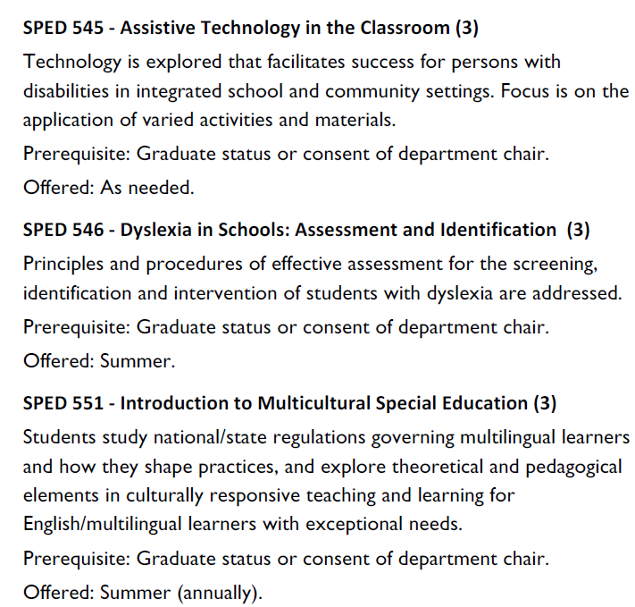

SPED 547 - Literacy: Students with Complex Learning Needs
Applying concepts of literacy to students with complex learning, physical and sensory needs is the focus. Students demonstrate proficiency in applying literacy practices in a 25-hour required literacy practicum.

Prerequisite: READ 534 and SPED 546 or consent of
department chair

Offered: Fall

